Week Twelve Report
Tic Tac Toe

159.356 Software Engineering Capstone Project 2013

Massey University

Group 2
Max Dietrich
Ryan Murphy
Sarsha Jones
Jesse Voight
Luke Christiansen
Jason Rurunanra
Table of Contents

1.0 Architecture………………………………..………………………………………………..3
1.1 High Level Design…………………………………………………………………..3
1.2 Client/Server Interaction………………………..………………………………….4
2.0 Quality Assurance……………………………………………………………………….….6
2.1 Test Coverage……………………………………….………..…………………….6
2.2 UI Testing…………………………………………..………………………………..6
3.0 Project Statistics……………………………….………..………………………………….7
3.1 Issues………………………………………………………………………………..7
3.2 Repository…………………………………………………………………………..7
4.0 Installation Manual……………………………..…………………………………………10
5.0 Customisation Manual……………………………………………………………………11
6.0 Check Out and Building of the Project………………………………………………….12
7.0 Requirements and Known Limitations..……………….………………………………..13
7.1 Requirements…..…………….……………………………………………………13
7.2 Limitations………………………………………………………………………….13
8.0 Commercialisation Plan…………………………………………………………………..14
9.0 Video Tutorial..…………………………………………………………………………….18
Appendix 1: Class Diagram………………………..…………………………………………….19

1.0 Architecture

1.1 High Level Design
The basic architecture of the game has essentially remained the same since the first prototype. Additional features have then been incorporated into this base architecture.

The project is split into a number of packages:

capstone.game
This package contains the classes related to the game itself, such as the rules and session details.

capstone.player
This package contains the classes that handle players and the default bot.

capstone.player.bot
This package contains the classes that handle the implementation of user-created bots.

capstone.server
This package handles all of the interaction between the players, on the client side, and the server. As such, most of the classes in this package are servlets.

capstone.server.jmx
This package contains the classes that allow for MBean inspections.

capstone.server.util
This package contains the classes that handle the interaction between the servlets in the capstone.server package and the rest of the classes on the server.

A class diagram is included as Appendix 1 which shows the interaction between the various classes in the project.

1.2 Client/Server Interaction

Interaction between the client and server is done through the use of java servlets on the server side. The following interactions take place:

Loggin in:
Player details are retrieved from Facebook or Google using JavaScript
index.jsp ➤ URL parameters (gid, fbid, name, email) ➤ SocialLogin.java

Viewing online friends for private game requests:
This information is included in the menu on each page. All online players are sent to the page using server sent events (SSE). These are then compared to a particular players Facebook/Google friends to display which of their friends are online and can be sent a private game request.
GoogleFriends.java & ➤ SSE (online Facebook/Google players) ➤ menu
FacebookFriends.java

Challenging a friend:
A player can select one of their online friends from the menu to send a game challenge to:
menu ➤ URL parameters (player ID, friend ID) ➤ SendPrivateGameInvite.java

Receiving private game challenge:
There is a separate menu item that shows on each page when a player receives a private game challenge. All private game challenges are sent to the pages using SSE. These are then compared to the particular player and are displayed if there is a match.
GameInvites.java ➤ SSE (game invites) ➤ menu

Accepting a private game challenge:
After receiving a challenge from a friend, a player can click on it to accept and be taken to the game.
menu ➤ URL parameters (friend name, friend ID) ➤ JoinPrivateGame.java

The game:
The state of the current game is sent by the server using SSE.
GameStateGet.java ➤ SSE (state) ➤ game.jsp
When a player makes a move, that is sent to the server using a POST request.
game.jsp ➤ POST (coordinates) ➤ MakeMove.java

Recorded games:
Recorded games are displayed using a GET request.
gamerecordmanager.jsp ➤ GET (type) ➤ GameRecordGet.java

Playing a bot:
The Bot Lobby page gets available bots using SSE.
GetBots.java ➤ SSE (all bots) ➤ botLobby.jsp
The bot that is selected to be played is done using a POST request.
botLobby.jsp ➤ POST (type, bot ID) ➤ GameCreate.jsp

Creating a bot:
The code is submitted to the server using a POST request.
boteditor.html ➤ POST (code) ➤ CodeSubmit.java

The menu items:
The JavaScript related to the menu are located in gamemethods.js.
singlePlayer ➤ POST (type, botname) ➤ GameCreate.java
multiPlayer ➤ POST (type) ➤ GameCreate.java
joinPublicGame ➤ POST (type, player) ➤ GameCreate.java
openGame ➤ POST (type) ➤ GameCreate.java

2.0 Quality Assurance

2.1 Test Coverage
The following reports show the coverage of the projects unit tests:
This shows generally good test coverage over the main game logic.

2.2 UI Testing
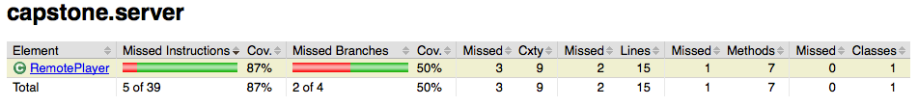
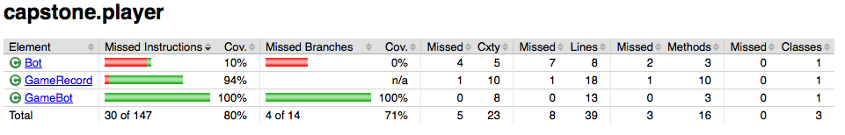
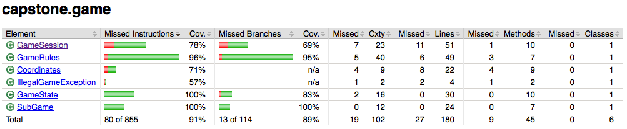
Extensive end user testing will be valuable in making the website more engaging and user friendly by increasing its usability. Throughout this project, there hasn’t been significant end user testing and this is evident in the mixed responses to the final product.

3.0 Project Statistics

3.1 Issues
The issue tracking system on GitHub, where the project repository is based, is used by the team to record issues. Since the inception of the project 68 issues have been opened.

Breaking down these issues, 25 are recorded as bugs, 11 as enhancements, 7 as invalid, and 4 as question. As the team uses the issue tracking system in a broad sense, recording details that need to be completed in order to fully implement a given feature that has been partially implemented, the non-labeling of the other issues is a reflection of this use of the issue tracking system.

In terms of number of issues opened, Max has opened 33, Luke 28, Jason 3, Sarsha 2, Jesse 1, and Ryan 1.

3.2 Repository
The following graph shows the number of commits over the life of the project. While there was a reasonably strong start, the amount of work done dropped around the mid-semester break but greatly picked up toward the end of the project.

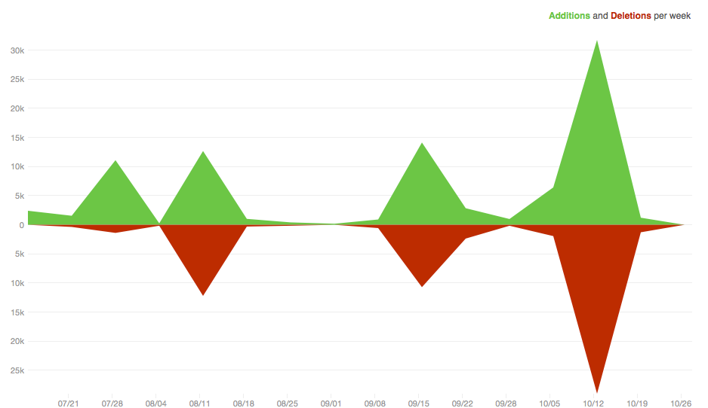
This is similarly reflected in the number of additions and deletions each week. As the graph shows, there were four distinct areas where the majority of the work was done; the team would spend a period of working hard, followed by a period of relative break.

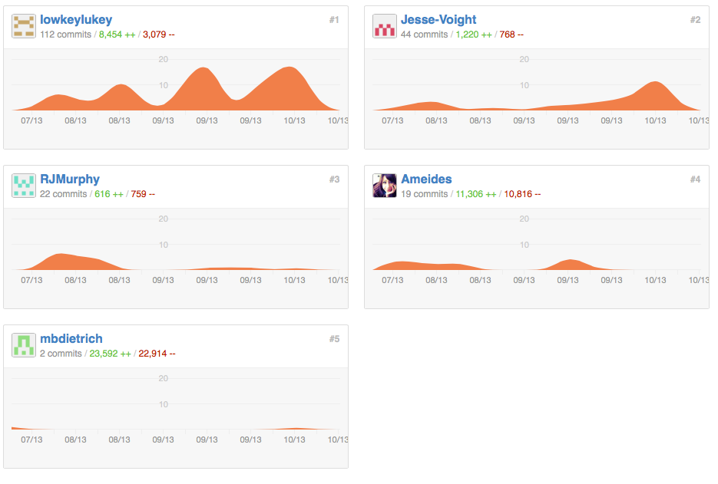
In terms of the break down of work between team members, GitHub provides the following graphs. However it should be noted that GitHub completely ignores one team member, Jason, and does not provide an accurate break down of the number of commits for each team member. As such, the following graphs are indicative only.

4.0 Installation Manual

The project is sell contained and does not require any set up to run. However, the following libraries are required and may need to be installed or located in order to run the final product:
- JUnit 4.10
- commons-codec-1.6
- commons-logging-1.1.1
- fluent-hc-4.2.5
- httpclient-4.2.5
- httpclient-cache-4.2.5
- httpcore-4.2.4
- httpmime-4.2.5
- asm-4.1
- JDK 1.7
- Apache Tomcat 7.0.34.0
While the project may work with different versions of these libraries, it has not been tested with any other versions.

5.0 Customisation Manual

The following aspects of the product are easily customisable:

Game rules:
The game rules are contained in the GameRules class in the capstone.game package. The methods in this class can be modified to enable the playing of a different game using the same board.

In addition, it would be relatively easy to create additional sets of rules to enable the playing of different games by having GameState reference the different set of rules.

Authentication:
Authentication is performed by way of passing URL parameters to a servlet, SocialLogin. It would be possible to allow for other means of logging in provided the player’s details are passed to SocialLogin. Note, however, that the friend features of the game require either a Facebook or Google ID to be present so those features would not work if a different authentication provider was used.

Default bot:
The default bot can easily be changed by modifying the “DEFAULT_BOT” attribute of the GameManager class.

User interface appearance:
The appearance of the user interface is controlled by the “style.css” file. As this css file is used by all web pages on the site, any modifications will affect the entire site. This makes it simply to change the appearance of the site.

6.0 Check Out and Building of the Product

The branch that should be checked out of the repository is “master”.

To build the product, it should be imported into NetBeans or Eclipse. From within the IDE the project can then be built or a war file created. While another IDE may also work, the building process has only been tested using NetBeans and Eclipse.

7.0 Requirements and Known Limitations

7.1 Requirements
The following are required in order for the product to run:
- Tomcat 7: The product has only been tested using version 7 of Tomcat. It is unknown if the product will work with earlier versions.
- Java EE 6: Only version 6 of Java EE has been tested. The product may not work with earlier versions, or version 7.
- Facebook and Google JavaScript SDKs: While the product currently works with these SDKs, it can not be guaranteed that the product will continue to work as Facebook and Google modify and update their SDKs.

7.2 Limitations
The following limitations are known:
- The game will not display in older versions of Firefox on Windows. This means that Firefox version 24 is at least required.
- The game board is flipped when using Firefox as opposed to Safari and Chrome.
- The “challenge menu” that displays when a player is challenged to a private game is inaccessible in Firefox and Chrome.

8.0 Commercialisation Plan

When thinking about earning revenue from a game, ads often spring to mind. While ad-supported games are fairly common, they typically do not have a high return. Obtrusive ads can be irritating enough for users to quit the game entirely, yet unobtrusive ones are often completely ignored, resulting in very little money-earning clicks. If we are fortunate, displaying ads may earn enough to cover server costs, but maintenance and site moderation also need to be considered.

For this reason, I have outlined some alternative options below. I have personally seen similar money-earning tactics used by other companies, such as Zynga, Zemi International, Kairosoft, AIGRIND, Gaia Interactive, and DeviantART.

- Custom Tokens
Instead of using the traditional X or O as their Tic Tac Toe token, the user can pay to upload an appropriately sized image to use in its place. This will be visible to both the user and their opponents. Some form of moderation will be required to ensure the contents of the image is family-friendly.

- Customized Site-wide Theme
The user can purchase a theme to modify the appearance of the site. The effects will only be visible to the user. A selection of default themes will be available to choose from, with the additional option to change backgrounds, fonts, color schemes, and general layout.
I personally don’t recommend this option, due to the amount of extra work it would involve to implement it and create the theme packs, especially as they are only visible to the user (i.e. the player won’t be able to “show off” their purchase to friends, so are less likely to buy it).

- Sound Packs
Alternative sound packs can be purchased to replace (or add to) the sounds in the game. E.g. a Microsoft Windows sound pack would play the Windows start-up music when a game begins.

Such packs would, again, only affect the user who purchased the pack.

- Game Themes
The user can purchase a custom or pre-set theme to alter the appearance of a game. E.g. A “Pets” theme would have a background of a lawn scattered with pet toys, and the X and O tokens replaced by a picture of a dog and cat, respectively. Such a theme could also include some sound alterations. The theme would be visible by both the user and their opponent. Once a game theme is purchased, it is available to use for any subsequent games for no additional charge for a month from the time of purchase. In the case where both the players have purchased a theme, the host’s one will be used.

- Profile Page Customization
Every user has their own profile page, to display basic information such as age, location, and hobbies, and link to their profile on other sites such as Facebook or Twitter. These are, however, fairly limited. Users will be able to purchase the ability to customize their profiles further, such as changing the background and layout, embedding videos and music, decorating whitespace with “stickers” or custom images, adding a shoutbox, and keeping a hit counter for visitors. This would also last for a month from the time of purchase, although their customizations should be kept in the database after expiry, so the user won’t need to build again from scratch each month.

- Bot Registration
While any user can create their own bot with the provided environment, the bot will only be playable by the user and the players on their friends list. To make a custom bot publicly visible and playable for everyone, it can be “registered” for a small fee. Registered custom bots will be displayed next to the default Easy/Medium/Difficult bots when a single-player game is being created. Registration will need to be moderated to ensure the bot name and description matches its function, and that it behaves appropriately.

- Experience and Levelling System
A levelling system can be put in place, where the users will have to collect enough experience points to progress to the next “level” by playing a number of games. A user can purchase items to give them experience more quickly (e.g. gain twice as many experience points from a game than a free user would have). Levelling up will unlock features in the game, such as themes, or items to decorate/modify their profile page with. A player’s level will be displayed next to their name in the game lobby and chats, giving an indication of the experience and hopefully fostering some competitiveness.

Unfortunately, this option has some serious drawbacks. It will require a lot of extra work to implement, and the fact that features will be “unlocked” eventually for free will reduce the motivation to purchase them outright. Nonetheless, it is still an option to be considered, especially if the site is expanded to include more games in the future.

- Premium Membership
A user can subscribe become a “premium member” for some fee each month, which includes some of the customization features above, in a single package. If they are also being sold separately, this package should cost less than the sum of its parts. This will also remove any ads from the game.

Purchase of In-game Items and Abilities
Instead of making each item/ability individual paypal or credit card transactions, a currency system will be implemented. “Coins” will be bought in packs of predetermined sizes, with a bulk discount for the larger purchases. Not only will these result in fewer overall transactions, which will be easier to manage, but it will dissociate the purchases of items with real money. E.g. “it’s only 250 coins” as opposed to “that’s $3 of real money coming out of my bank”. It’s also likely that a user will have some number of coins left after their intended purchases, which aren’t quite enough to buy anything of use. To them, this is already paid for and should be used, so they are more likely to supplement their store of coins by purchasing one of the smaller packs in order to buy something else.
Coins could also be rewarded for some achievements in the game, as a sample to encourage users to buy coin packs.

Expected Revenue
While the companies mentioned at the start of this document are doing well with similar tactics and strategies, our success will depend a lot on how many active users we can attract to the game. A very large set-back is the nature of the game itself, as Tic Tac Toe is a very simple and not particularly addictive game. It is doubtful whether any user will put in the time and effort to level up, or whether it becomes popular enough to make profile customizations worth it from a player’s point of view. After a few games, there is very little to keep a user from leaving the site.

9.0 Video Tutorial

A video tutorial has been produced that explains how to use the site and shows off the features. It can be viewed at:

Appendix 1: Class Diagram

